**Muhammet Taha ADIYAMAN  | Oğuzhan BOZKURT**

**181005039 181005050**

Database Management System

**Inventory Control Management**

**Inventory Control Management**

**What is Inventory ?**

Inventory refers to all the items, goods, merchandise, and materials held by a business for selling in the market to earn a profit.

Inventory management has passed through various developments from the past to the present. The earliest form of inventory management dates back over 50,000 years in which people used “tally sticks” to count. Over time, inventory management developed into slightly more accurate systems of accounting and record keeping, particularly in ancient Greek and Egyptian societies.

The start of the second industrial revolution brought incredible breakthroughs for inventory management. Herman Hollerith, an American inventor, developed the first modern automatic computation machine. Replacing pen and paper and saving countless hours of time, the tabulator and sorter machine was specially designed to record information using punch cards. These punch cards allowed people to record many types of data, including inventory.

Since the mid-1970’s, the barcode has predominately been many industries’ primary inventory management tool. In the late 1940’s, Norman Woodland invented the barcode due to a request from a distraught grocery store owner who needed help keeping track of inventory.

After the various development, Radio frequency identification (RFID) technology, similar to barcodes in terms of data collection, was first patented in the 1970s and uses radio waves for the identification of items. A microchip with an antenna contains a series of identification numbers, and together, the microchip and the antenna (the RFID tag) are passed through a chip-reader, which reads the information and places it onto a computer. Today, RFID technology is more efficient and accurate than the bar code system. For example, with bar codes, the device that scans the bar code has to be able to directly pass over the bar code itself. This usually means that people have to physically orient the bar code within accurate range of the scanner. Furthermore, bar codes can rip or become dirty, making it difficult for the scanner to identify the object.

Inventory is a major asset for any manufacturing or trading business, so it’s important for business owners to understand what it really means.

**Therefore, we chose this project as our team to better understand and make the inventory control method more effective for companies.**

**Features Of Inventory Control Management**

metin içeren bir resim

Açıklama otomatik olarak oluşturuldu**1-Inventory Management Module**

* Categorization of products in stocks
* Measurement of products
* Inventory/Products history
* Cycle counting
* Livestock reports
* Vendor management
* eCommerce
* Total Inventory Management

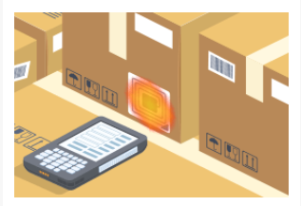**2-Barcoding & Tagging**

* Scan barcode easily
* Faster performance
* Records things faster than the workforce
* Get precise details of products
* Locate products
* Barcode and Tagging

metin içeren bir resim

Açıklama otomatik olarak oluşturuldu**3-Inventory Tracking**

* Product tracking
* Tagging
* Reports and audits
* Inventory Tracking Solutions

**4-Reporting Tools**

* metin, oyuncak içeren bir resim

  Açıklama otomatik olarak oluşturulduSmooth and flawless communication
* Enhanced Productivity
* Reduced common human error
* Reporting Tools for Inventory Management
* Business who actively manage their inventory

report a 2-10% increase in sales

**metin, işaret, ekran görüntüsü içeren bir resim

Açıklama otomatik olarak oluşturuldu5-Inventory Alerts**

* Reduced stock waste
* Optimised inventory levels
* Improved cross department visibility of stock data
* Helps manage your Investment Style
* Drive sales
* Maintain operational control Inventory Alert

**metin içeren bir resim

Açıklama otomatik olarak oluşturuldu**

**oyuncak içeren bir resim

Açıklama otomatik olarak oluşturuldu**

**metin, işaret, ekran görüntüsü içeren bir resim

Açıklama otomatik olarak oluşturuldu6-Cloud-Based Software with Real-Time Updates**

* Cost Savings
* Ease of access
* Always Safe and Secure
* Real-Time visibility
* Enhanced Efficiency
* Improved Coordination
* Cloud Integrated Inventory Management

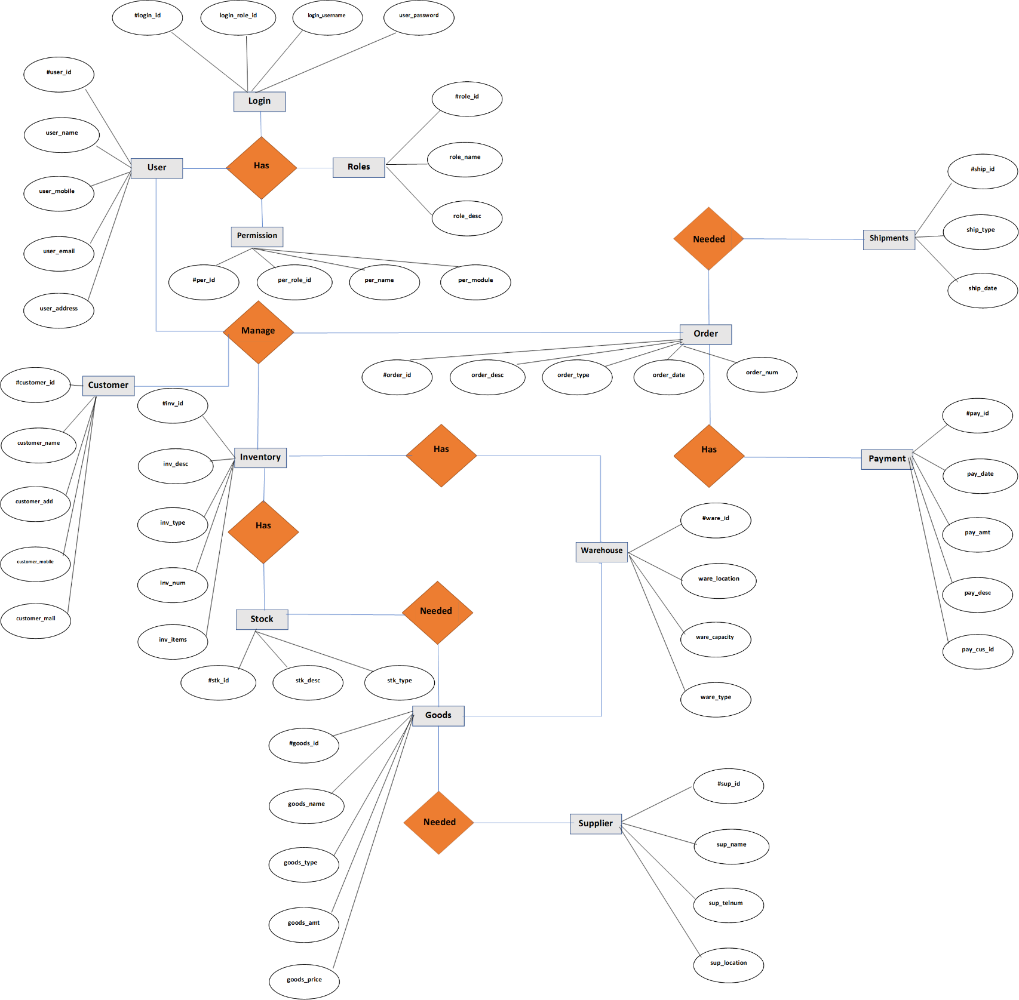ENTITY DIAGRAM AND ER DIAGRAM

